# Steps to set up salary-api

**Step** **1**: Configuring your AWS environment.

1. **Log in to the AWS account**:

◦ Go to your AWS Management Console.

2. **Create an EC2 Instance**:

◦ Go to the EC2 Dashboard.

◦ Click **Launch Instance** and configure the following:

▪ **AMI**: Ubuntu 22.04.

▪ **Instance Type**: t2.medium.

▪ **Key Pair**: Create or select an existing key pair.

To create a key pair, follow these steps -

1. Go to key pairs and click on **Create key pair**.
2. Provide the key name, key pair type, and key file format as per your requirement.

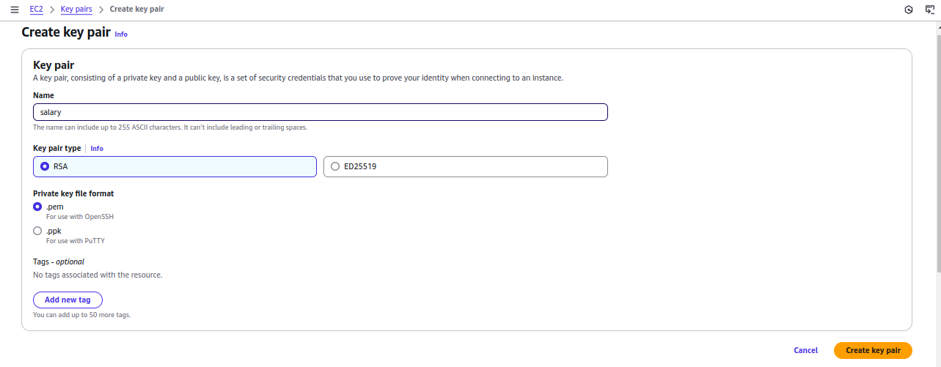

▪ **Security Group**: **Inbound rules**:



• 22 [ for SSH ]

• 8080 [ for web servers ]

• 80 [ for HTTP ]

• 9042 [ for ScyllaDB ]

• 6379 [ for Redis ]

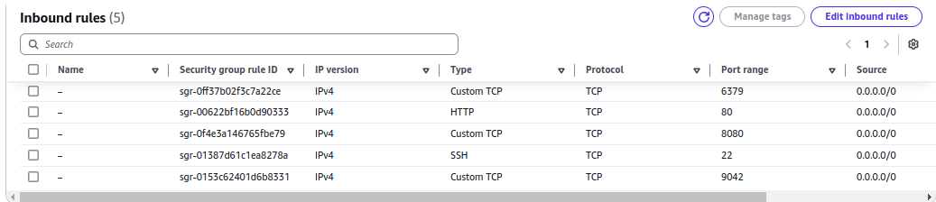

**Outbound rules**: Allow all traffic

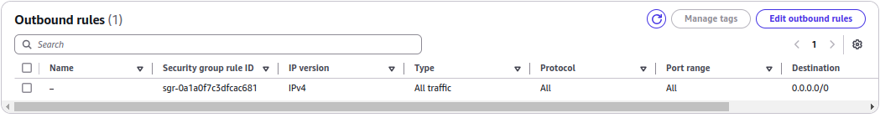

**Access the EC2 Instances**:

• SSH into the EC2 instances using the following command:

**ssh -i your-key.pem ubuntu@<ip>**

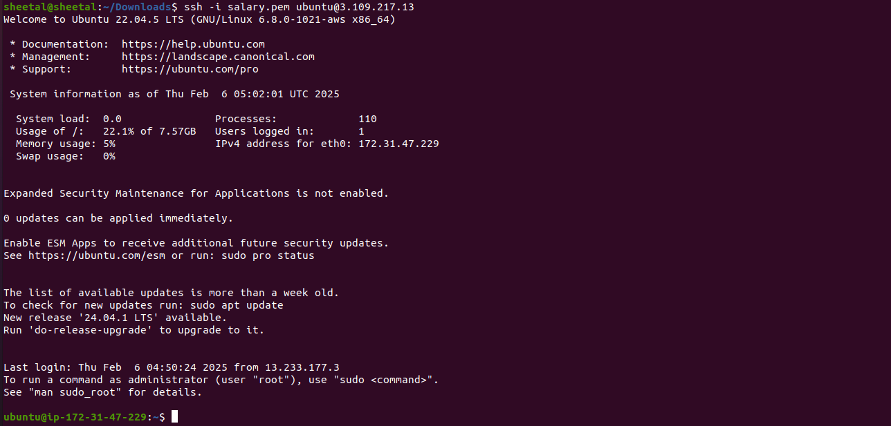

**Verify the Key and its permissions**.

1. Ensure the key file is correct:

◦ Double-check that the pem key is the private key associated with the EC2 instance.

2. Ensure the key file has the correct permissions: **400.** [ 4 - user/owner, 0 - group, 0 - others ].

To set the required permissions to the key run the following command :

**Chmod 400 salary.pem**



**Step 2**: Once we have the server ready, make sure to install all the dependencies that are required. The **dependencies** that we require are -

* **Maven**
* **Redis**
* **Migrate**
* **Sycalladb**
* **make**

**Step 3:** Scylla Installation, run the following commands.

sudo mkdir -p /etc/apt/keyrings

sudo gpg --homedir /tmp --no-default-keyring --keyring /etc/apt/keyrings/scylladb.gpg --keyserver hkp://keyserver.ubuntu.com:80 --recv-keys a43e06657bac99e3

sudo wget -O /etc/apt/sources.list.d/scylla.list

<http://downloads.scylladb.com/deb/debian/scylla-6.2.list>

sudo apt-get update

sudo apt-get install -y scylla



**Step 4**: Make some changes to the scylla.yaml

**sudo vi /etc/scylla/scylla.yaml**

seeds: private ip



listen_address: private ip



rpc_address: private ip



add the below code in scylla.yaml-----

authenticator: PasswordAuthenticator

authorizer: CassandraAuthorizer



**Step 5**: Configure the I/O settings for ScyllaDB.

sudo /opt/scylladb/scripts/scylla_io_setup



**Error:** Disk space error.

**Solution**: Resize the volume.

* Stop the instance.
* Go to the **EC2 Console** → **Volumes**, select your root volume, and modify its size to 15GiB
* Restart the instance after the resize.

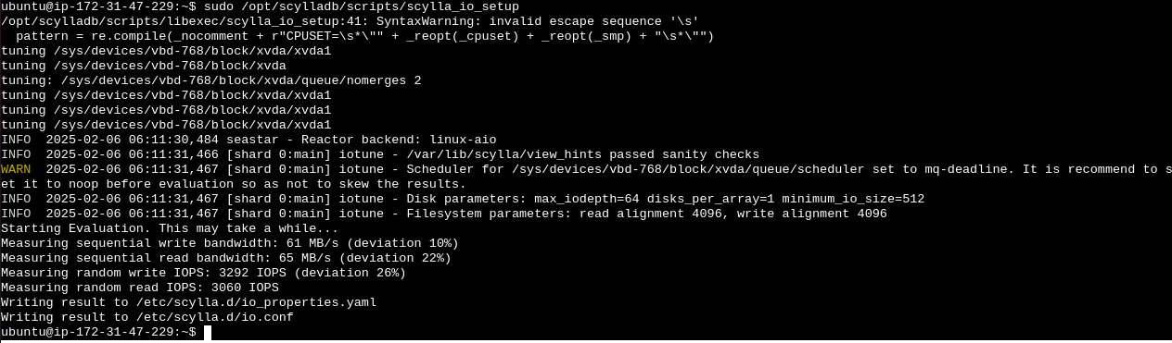

**Start the Scylla server and check its status.**

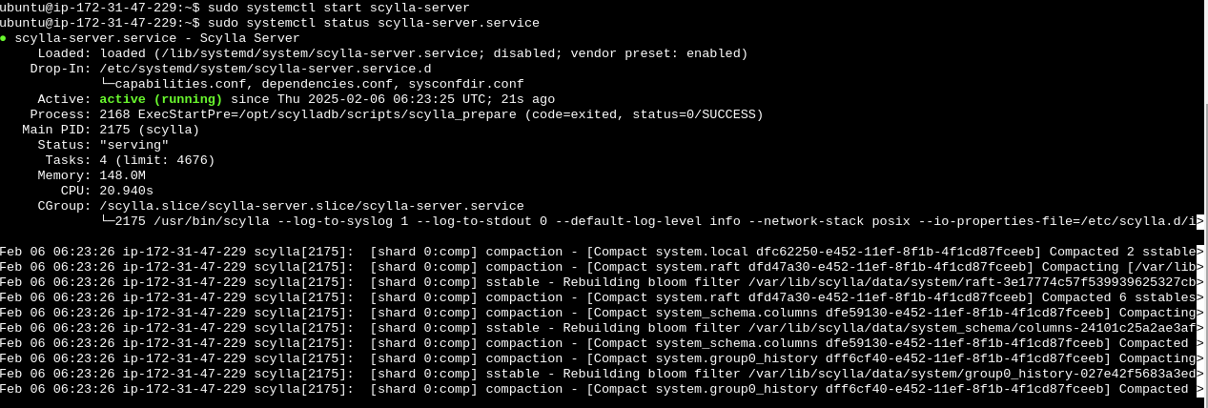

Check the Cassandra cluster for node information, with the help of the following command:

**nodetool status**

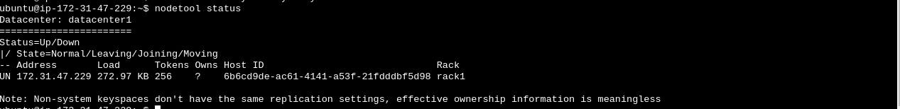

The status shows **UN** which means up and normal.

**Step 6: Connect to Cassandra using cqlsh**: cqlsh 172.31.47.229 -u cassandra -p cassandra

**Create a new user scylladb**: CREATE USER scylladb WITH PASSWORD 'password' NOSUPERUSER;

**Grant all permissions to the new user**: GRANT ALL PERMISSIONS ON ALL KEYSPACES TO scylladb;

**Create employee_salary keyspace**: CREATE KEYSPACE IF NOT EXISTS employee_salary WITH replication = {'class': 'SimpleStrategy', 'replication_factor': 1};

**Create employee_DB keyspace**: CREATE KEYSPACE IF NOT EXISTS employee_DB WITH replication = {'class': 'SimpleStrategy', 'replication_factor': 1};

**Describe keyspaces**: Describe keyspaces;

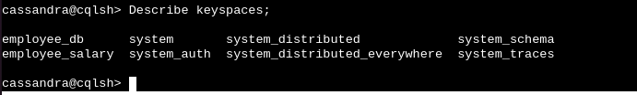

**Switch to employee_db keyspace**: use employee_db;



**Create the employee_salary table**: CREATE TABLE IF NOT EXISTS employee_salary (

id text,

process_date text,

name text,

salary float,

status text,

PRIMARY KEY (id, process_date)

) WITH CLUSTERING ORDER BY (process_date DESC);

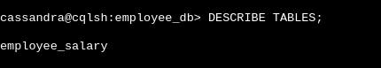

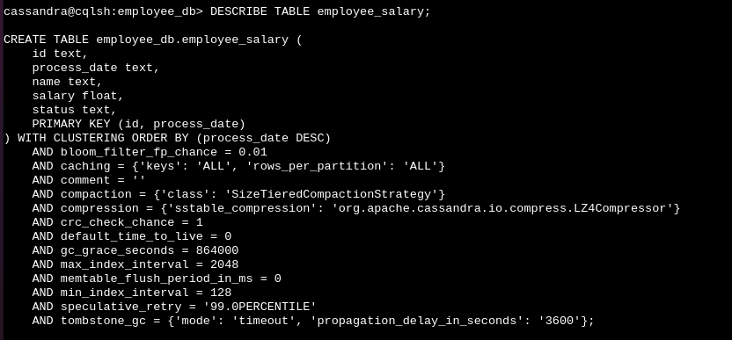

**Exit the cqlsh session**: exit.

**Step 7**: **Redis installation**. Run the following commands -

sudo apt-get install lsb-release curl gpg

curl -fsSL <https://packages.redis.io/gpg> | sudo gpg --dearmor -o /usr/share/keyrings/redis-archive-keyring.gpg

sudo chmod 644 /usr/share/keyrings/redis-archive-keyring.gpg

echo "deb [signed-by=/usr/share/keyrings/redis-archive-keyring.gpg] <https://packages.redis.io/deb> $(lsb_release -cs) main" | sudo tee /etc/apt/sources.list.d/redis.list

sudo apt-get update

sudo apt-get install redis

sudo systemctl enable redis-server

sudo systemctl start redis-server



**Configure Redis** - sudo vi /etc/redis/redis.conf

bind <private ip>



Connect to Redis: redis-cli

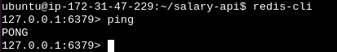

Grant the user Scylla permission to run all Redis commands: ACL SETUSER scylla on >password ~* +@all

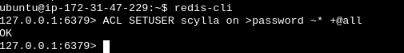

**Step 8: Install Maven** with the help of the following commands:

sudo apt install maven -y

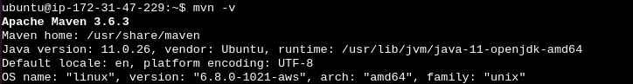

**Step 9: Install JAVA 17.**

sudo apt install openjdk-17-jre-headless -y

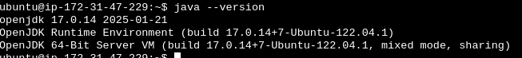

**Step 10: Install make.**

sudo apt install make -y

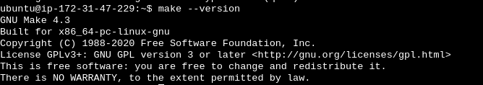

**Step 11: Install migrate.**

curl -s <https://packagecloud.io/install/repositories/golang-migrate/migrate/script.deb.sh> | sudo bash

sudo apt update

sudo apt install migrate -y



**Step 12: install jq.**

sudo apt install jq -y



**Step 13: Clone the salary-api repo.**

git clone <https://github.com/OT-MICROSERVICES/salary-api.git>

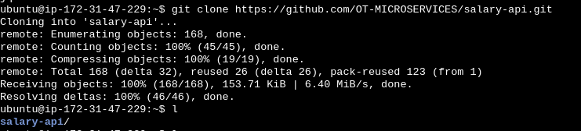

**Step 14: Configure additional settings to interact with the database.**

* Switch to salary-api directory.



* Replace the IP with your private IP in migration.json: Sudo vi migration.json



* /src/main/resources/application.yml - 172.31.47.229

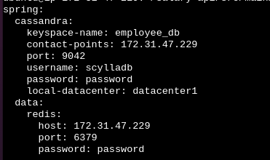

* /src/test/resources/application.yml - 172.31.47.229

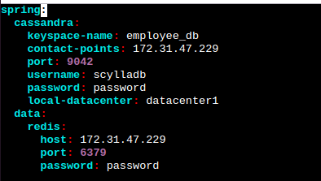

**Step 15: Update the OpenAPIConfig.java file**.

sudo vi src/main/java/com/opstree/microservice/salary/config/OpenAPIConfig.java

[ replace the localhost URL in the devServer setup with the public IP address of your server]

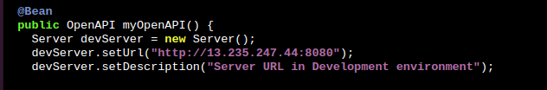

And add the following block.

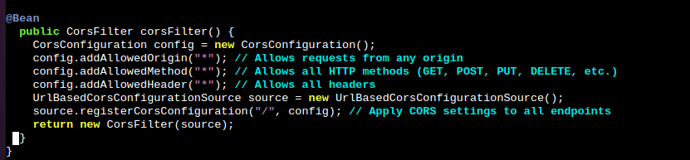

**Step 16: Update the OpenAPIConfigTests.java file.**

sudo vi src/test/java/com/opstree/microservice/salary/config/OpenAPIConfigTests.java

[ replace localhost with your server public ip this line - assertEquals("http://localhost:8080", server.getUrl());]

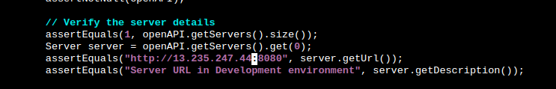

Step 17: Run the following commands.

* make run-migrations
* make build

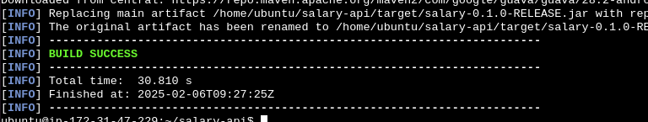

* make fmt
* make test
* java -jar target/salary-0.1.0-RELEASE.jar

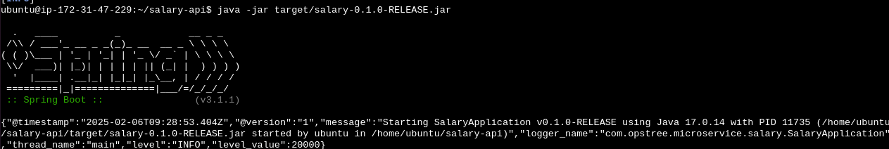

**Step 18: Hit the address.**

<http://ipaddress:8080/salary-documentation>

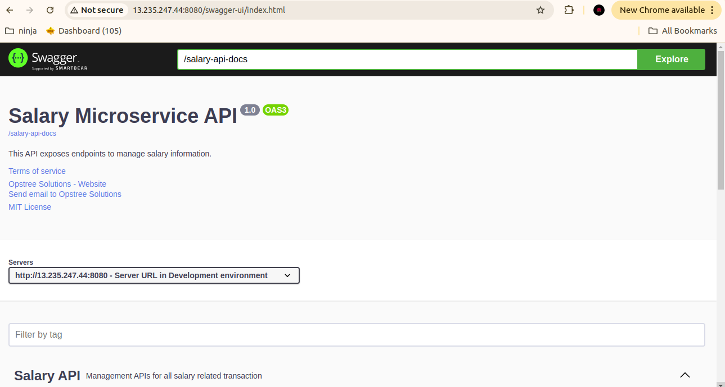

java -jar target/salary-0.1.0-RELEASE.jar

or

create the service file if required using below code(optional)

sudo vi /etc/systemd/system/salary-api.service

++++++++++++++++++++++++++++++++++++++++++++++++++++++++++++++++++++++

[Unit]

Description=salary api

After=network.target

[Service]

Type=simple

User=ubuntu

Group=ubuntu

WorkingDirectory=/home/ubuntu/salary-api/

ExecStart=java -jar /home/ubuntu/salary-api/target/salary-0.1.0-RELEASE.jar --server.port=8080

Restart=on-failure

RestartSec=5

StandardOutput=journal

StandardError=journal

[Install]

WantedBy=multi-user.target